Ragade’s Cube Engine
Software Design Document
Table Of Contents

1. Intro 3
1.1 Purpose 3
1.2 Scope 3
1.3 Definitions & Acronyms 3
2. References 4
3. Decomposition 5
3.1 Module Decomposition 5
3.1.1 SceneGraph 5
3.1.2 Rendering 6
3.1.3 Picking 6
3.1.4 GUI 6
3.1.5 StateManagement 7
3.1.6 Input 7
3.2 Concurrent Process Description 7
4. Dependency Description 8
4.1. Inter-module Dependencies 8
4.2. Inter-process Dependencies 8
5. Interface Descriptions 8
5.1 Module Interface 8
5.1.1 SceneGraph 8
5.1.2 Rendering 10
5.1.3 Picking 11
5.1.4 GUI 11
5.1.5 StateManagement 13
5.1.6 Input 15
6. Detailed Design 16
6.1. Module Detailed Description 16
6.1.1 SceneGraph 16
6.1.2 Rendering 18
6.1.3 Input 19
6.1.4 GUI 24
6.1.5 Picking 26
6.1.6 StateManagement 28

1. Intro

The Ragde’s Cube (RC) Engine is a game engine to be made for the Ragde’s cube game. Though it was made for the specifically for the Ragade’s Cube game, it is intedned to be used for all gaming applications. The game engine is based on the Managed Microsoft XNA framework. Since the XNA technology is relatively new, there is a lack of full fledged engines available. The RC engine will demonstrate the minimum requirements to fulfill a game.

1.1 Purpose
This document describes the detailed design of the RC Engine. The purpose of this design document is to provide a detailed design of all game components for the Ragade’s Cube project.

1.2 Scope
This document is intended to show the partitioning between the various entities in the game engine and their hierarchical dependency relationships. This document also defines the interfaces that the various designers, programmers, and testers will need to understand in order to use the system. Lastly, this document shall describe the detailed design of each entity within the game engine.

The entities of the engine that will be documented are
- SceneGraph
- Rendering
- Picking
- GUI
- StateManagement
- Input

1.3 Definitions & Acronyms
Camera – Viewpoint for rendering a scene that is a scene node.
Engine – Provides prepackaged game functionality to make game development simpler.
GUI – Graphical User Interface. For the engine, it is a system that manages object that can be interacted with
Picking – A term used to refer to the process of selecting a 3D object from 2D screen coordinates (from a mouse click for example)
Rendering – The process of taking 3D dimensional data and transforming it to 2D screen space. (Rasterization)
State – A phase of a game that is exclusive to other phases.
Homogeneous Matrix Transformation – Process of applying a translation, rotation and scaling to a vector or other Homogeneous Matrices.
XNA – Microsoft’s framework for Game Development.

2. References

3. Decomposition
The engine is broken down into separate components that define the entire engine functionality; the game engine includes the components that are being pre-packaged in a manner that could later be used for general game creation.

These components include:

- Picking –GUI –
- StateManagement –Input – Abstracts input. Also contains support for local input devices such as mouse, keyboard, and gamepad.

Most modules are integrated into the same distributed library but live in different namespaces.

3.1 Module Decomposition

The modules will be divided further into its constituent classes and namepaces

3.1.1 SceneGraph

This module is about representing graphical elements in a hierarchical fashion to manage their Drawing, Updating, and Loading. This module allows for the creation of hierarchical object trees called scene graphs. Scene graphs represent a scene to be rendered. Many places though out the engine are scene graphs referenced. The entire graph can be referenced by referencing its root scene object. Most operations on the scene graph are recursive and affect the entire tree.

The following classes define the SceneGraph module.

Class Division
  - Spatial
  - SceneNode
- Animation
  - AnimationController
- BoundingVolumes
  - BoundingVolume
  - BoundingShpere
  - BoundingBox
  - BoundingRect

Interface Division
  - ISpatial
- INode

    - Rendering

Rendering is responsible for correctly displaying graphical elements on the screen. Specifically, the rendering system hosts to drawing scene graphs. The rendering system has its own scene graph objects for the aid of creating lighting effects and managing the viewpoint of a scene. The Rendering component can apply lighting, texture mapping, lighting materials, and rendering coordinates to scene objects. The scene objects themselves will make use of the rendering module to draw their visible representations.

Class Division
- RenderManager
- LightNode
- CameraSystem
    - CameraManager
    - Camera
    - OrthographicCamera
    - PerspectiveCamera
    - Picking

The Picking system allows scene graph objects to be selected using a ray. The system also can determine what was selected by a mouse event. A couple of components use the picking system. The GUIManager will use it to determine what GUIObject was selected, while specific game states will use it to see what objects were selected by the user.

Class Division
    - PickingManager
    - PickRecord

    - GUI

The GUIModule is responsible for managing user interaction with the graphical elements of the game engine. The GUI System defines its own scene graph system using the same base scene graph object as the SceneGraph module. The GUI System mainly supports flat 2D rectangular objects, however, any object can be notified of user interaction through the IGUIElement interface.

Class Division
    - GUIManager
- GUISceneObjects
    - GUIObject
    - Pane
    - Control (and derivitives)
  - Scenes
    - GUI2DScene
  - Primitives
    - Quad
    - TextQuad
    - ImageQuad

Interface Division
    - IGUIElement

3.1.5 StateManagement

This module defines and manages game states that define the game experience throughout different phases of the game. The GameState class represents a single part of a game; usually a state represents the different screens of a game. The StateManager manages all the created states in the form of a stack.

Scene management is placed in state management because a scene manager is an object made for the GameState class. As a state will have many different scenes, GUI scenes, 3d scenes, etc, the scene manager will keep track of the loading, updating and drawing of the scenes, a tedious task to do manually.

Class Division
- StateManager
- GameState
- SceneManagemet
    - SceneManager
    - Scene

3.1.6 Input

The input system abstacts input of all forms. The input system supports standard periphial inputs, such as the mouse, keyboard, and gamepads, but also can support any kind of input. The specification of the watcher class defines what kinds of events to watch for.

The input module is dividedn into abstract input and periohial input. These prorived input functionality for the RC Engine.

The detailed design documents the various classes and their functions.

3.2 Concurrent Process Description *
The game engine runs in a single-process loop, and thus contains no concurrent processes. Additionally, the game engine has no other processes..

4. Dependency Description *
This section of the document describes the dependencies that occur within the Ragade’s Cube Game.

4.1. Inter-module Dependencies *

The UML diagram communicates the dependencies.

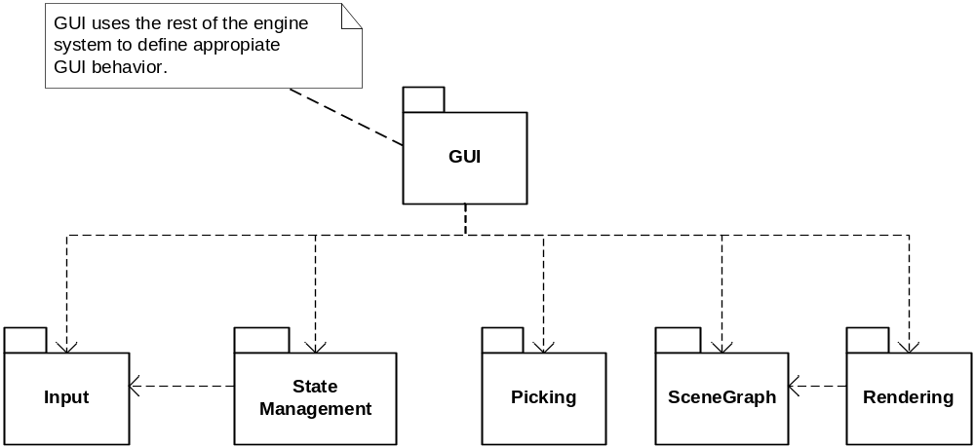

4.2. Inter-process Dependencies *
The game engine and the game logic run in a single-process loop, and thus contain no concurrent processes between them.

5. Interface Descriptions
The publicly exposed items will be discussed and explained in this section. It is assumed that since the items are public, they are the things that will be used to interact with the modules. Using the classes discussed below is key to utilizing the engine.

5.1 Module Interface
The classes and their functions will be discussed for each engine component.

5.1.1 SceneGraph

Interfaces
ISpatial – Outlines the core funtions of a scene graph object.
INode – Outlines functionsof a scene graph object with children.
Classes

Spatial

Spatial is the base of a scene graph object. It is abstract and must be overridden. For an object to exist in a scene graph, it must derive from this class.

Spatial also realizes the ISpatial interface. Spatial exists at the leaves of the scene graph. It is natural to derive items that have geometric data from spatial.

SceneNode

SceneNode is derived from Spatial and adds the ability for a scene graph object to have Spatial-derived children. Add children with the AddChild method. Node will also update its world bound to contain all of its children’s world bounds.

AnimationController

Every Spatial object has a list of AnimationControllers. Animation controllers modify the objects that they are attached. This allows for updating of time varying values, such as the animation of objects. The controller will often modify the location of the object, so it is to be updated with the objects world data.

BoundingVolume

BoundingVolume is an abstract class defining a general bounding volume for applying limiting bounds to geometric data. As bounding volumes can take on many different shapes, this class represents the commonalties to all of them. All Bounding volumes are expected to be able to convert themselves into a bounding sphere. In addition, they all must be able to perform intersection tests, with a Ray and a Plane object. Also a bounding volume should be able to be transformed by a matrix transformation.

AxisAlignedBoundingBox

AxisAlignedBoundingBox defines a bounding volume that is a rectangular prism that has all of its edges aligned with the axis. This ensures collision tests are compute quickly.

BoundingShpere

The BoundingShpere class represents a spherical bounding volume. Collision tests with other spheres are very simple and transformations of BoundingSpheres are too. They require no computation towards the rotation of the sphere.

BoundingRect

The BoundingRect class defines a bounding volume in the form of a flat rectangle. BoundingRects should be used when the geometric contents of a scene object is flat.

5.1.2 Rendering

Rendering supports the drawing of scene graph objects.

RenderManager

The render manager exposes many functions relating to the drawing of a scene graph object. The RenderManager provides a function for setting the current drawing coordinates, function for setting the current material, functions for enabling the directional lighting, a function for setting the current lighting material, and a function for rendering a scene graph.

LightNode

The LightNode class is derived form the SceneNode class. The light node provides the ability to illuminate objects contained within a scene graph. Use this object by adding it to a scene graph as a parent of all things you would like to be illuminated by the light. There can be up to four directional lights in the scene, and each has to refer to a different RenderManager directional light. If the same light is referenced while it the light is enabled, an exception will be thrown.

Camera

A camera object defines a particular viewpoint, viewport, and projection for rendering a scene. The camera can be position through out the world space and therefore is a scene graph object. Additionally, the camera calls derives from SceneNode. This means that the node can be attached to scene graph nodes and scene graph objects can be attached to the camera.

The camera class is abstract and must be overridden to define the kind of projection the camera will use.

OrthographicCamera

The orthographic camera derives from camera and defines an orthographic projection. The orthographic camera also exposes public properties for modifying the orthographic projection to be updated on the next update pass.

PerspectiveCamera

The perspective camera derives from camera and defines a perspective projection. The camera also exposes public properties for modifying the perspective projection to be updated on the next update pass.

CameraManager

The camera manager aids the RenderManager in determining what view and projection matrices to use for rendering scene graph objects. The CameraManager keeps track of a list of cameras that can be accessed though a string label. Any camera can be set as the currently active camera. The active camera will be the one used by the render manager for drawing.

5.1.3 Picking

PickingManager

The picking manager exposes two main functions for determining selected objects. One function determines the lists of objects that are selected by screen coordinates. The other determines all of the objects that intersect with a given ray.

The first function is useful for determining what objects were clicked on by the mouse. The second is used in the first application and for others such as laser beam shots, determining the height above terrain, etc.

PickRecord

A pick record is the class that contains the list of objects returned by the picking manager. Objects are sorted form closest to furthest. The list of items can be retrieved from the pick record. Also, the pick record can filter on unwanted or wanted types. This helps to narrow the candidates down when trying to figure out what was selected by the user.

5.1.4 GUI

GUIManager

The GUIManger manages a scene with IGUIElements in it. The GUIManager is responsible for informing the IGUIElements those user events has occurred in its bounds. The GUI manager will need to be informed of user input. Therefore, the GUIManager defines its own control scheme type: GUIInputScheme.

GUIInputScheme

The GUIInputScheme is an abstract class that derives from InputScheme<GUIMANAGER>. This defines an InputScheme to have GUIManager as its generic argument

GUIStandardInputScheme

This class defines all the intuitive user input for controlling a GUI scene. Use it when no unconventional GUI input is required.

GUIObject

Is the base object for the GUI System. It is a fat rectangular scene graph object that derives from Spatial. It is used for all things 2D and can be oriented in any direction in 2d space. It also can be attached to non GUI scenes as it still is a scene graph object.

Also, GUIObjects expose properties defining their size in pixels. Usually pixel size corresponds to the screen but in some cases it does not have to.

The GUIobject also realizes the IGUIElement interface.

Pane

The pane class is a GUIObject that has GUIObject children. Children GUIObjects can be added thought the AddChild function. As GUIObjects are added, the parent pane must resize the child to match the Pane’s pixel resolution; this ensures that GUIObject children are the correct size in terms of the parent’s pixel width and height.

GUI2DScene

This class provides easy creation of 2d scenes. Given a viewport on the screen, the class will automatically create a Orthographic camera and a Pane scene root that represents the screen. Users must access the screen pane to add GUIObjects to the scene graph.

Quad

The quad class is a drawing primitive defined just for the GUI system. A quad is a flat reactngle postionable in any orientation in space. It too drives from GUIObject. Quads are the visible components of an object using th GUI system. A GUIObject will use a quad to display image and text data.

ImageQuad

An ImageQuad is a quad with a texture mapped image. This defiens arectange with a picture on it.

TextQuad

A TextQuad is quad with text pasted to it. It is used for displaying text in the GUI system.

5.1.5 StateManagement

StateManager

The state manager class manages the different game states in the form of a stack. The Currently visible state is on top of the stack. When ever a stat needs to transition, there are a few options. The old state can call into the StateManager and push on the new state, it can call and replace all the states with a new state, or it can call and pop itself of the stack. When a state is popped of the stack, the state directly underneath is preserved and it is returned to as if no timer ever had passed.

Thie is useful for managing game flow.

GameState

The GameState class defines certain exclusive phases of a game. A state can have multiple scenes to render, its very own input manager, and specific game. The state makes available all of these services for the game. Override the update and draw functions of the state to add state specific behavior. Also any input events that are being watched only affect the current state and none others.

SceneManager

Every state has a scene manager for maintaining multiple scene graphs at any time. The Scene class keeps a list of Scene classes. New Scenes can be added to the scene system by using the AddScene function. The SceneManger will allow the list of scenes to be accessed though a property.

Scene

The Scene class keeps an active camera and a root node of a scene graph for managing one scene graph tree. The scene exposes functions for Drawing, Loading, and Updating the scene tree. When it comes tiem to draw, the scene class switches the CameraMangers, active camera to the one refrenced by the scene. This ensures each scene is drawn with the correct camera.

5.1.6 Input

The input system allows for event an event based input system. Watchers are to expose events and are updated by the InputManager class. When the status of input devices is desired, the appropriate watcher is created and added to the input manager. The manager will invoke the update function on the watcher. The when certain input events occur, publicly visible events in the watcher are raised to invoke any attached delegates.

The watcher class is abstract and has abstract methods for updating.

The engine also includes default specifications of the watcher class for peripheral inputs such as the mouse and keyboard. The watchers expose keyboard and mouse related events and are invoked when key events or mouse events occur.

The input system also defines a templated InputScheme class. The class’s responsibility is to map a watcher’s events to a given object’s functions. The Generic InputScheme class takes a generic type argument. This generic type is the type of the object that will have its functions mapped to watcher events.

The Apply(T object) function of the InputScheme will keep a reference to the object and then call MapWatcherEvents(). This abstract function will be overridden to explicitly assign the object’s functions to a created watcher’s events

6. Detailed Design

For the designs below: PLEASE SEE THE ACCOMPANIED UML DIAGRAMS IN THE SEPARATE VISO FILE. The number of diagrams is immense and not all of them are alluded here. To get a good feel for the structure of the systems, please see the document!

6.1. Module Detailed Description

The engine provides support for the following, scene graph construction and maintenance, rendering of scene graph objects with effects, game state creation and management, state specific input handling, and a GUI system with GUI managed controls.

These are the functionalities common to most games and re pre packaged for games to make use of immediately.

Most of the functionalities mentioned depend on other sub parts within the engine. Each sub-module will be discussed in detail.

6.1.1 SceneGraph

A scene graph is a tree based representation of a scene. Graphical elements are arranged in a hierarchical fashion where every object has a parent object except for the root object.

The base for all scene graph objects is the RCSpatial class. This class assumes that every scene graph object will have:
- A position/orientation in 3d space
- Some kind of bounding volume that encompasses its contents
- A parent

Node classes are a specialized form of Spatial objects; nodes provide the ability for a scene object to have children. The tree structure is accommodated through the composite pattern achieved by RCSpatial and RCNode. Together, they provide the ability to form a scene graph. (See SceneGraph class diagram.) You may think of nodes being interior to the tree as spatial objects can only exist at the leaves.

These scene graph classes support recursive drawing and updating of all scene objects in a tree. Updating is needed whenever the graphic state of the tree has changed, as when the position of an object has moved.

Each scene object has a local position and an absolute (world) position. The local position is the object’s position in space relative to its parents. The world position for each object in a tree is computed from a recursive update pass. The world locations computed from their parent position and their local relative position.

The update pass must update object positions and any time varying data on the down pass and update object bounding volumes on the returning up-pass. This allows for the bounding volumes to be properly sized as the BVs are recalculated after the objects are in their final positions. Bounding volumes are intended to define a 3d volume that contians the geometric contents of a scene object. The BVs aid in collision testing purposes. However since spatial objects do not define their geometric contents, they cannot define a bounding volume and hence, have an abstract function: UpdateWorldBound().

Derived classes override this method to ensure the world bound is correctly sized and positioned to contain the classes geometric data. A cube scene object, for example, would derive from spatial and define a bounding box that tightly encloses the cube through its UpdateWorldBound() function.

Node and similar classes can define their bounding volumes whereas Spatial can not. Nodes compute their bounding volumes to be the minimum volume that can encompass all of its children’s volumes. This functionality makes it possible to reduce the search time for identifying collisions; the check for collision is recursively tested from root to leaf of a tree. If the parent’s bounding volume does not intersect the testing object, it can be assured that all of its children do not as well. (DESIGN GOAL: collision testing)

Scene objects support animation though a list of animation controllers. Each scene obecjt has its own list. All animation controllers are updated when the object’s world data is updated. This is because an animation controller often changes the position of its attached object. The controllers and spatial classes comprise the decorator pattern as it is possible to add functionality as new kinds of controllers are added. (DESIGN GOAL: animate objects)

The updating of Node and Spatial define the semi-complex breadth and depth-first tree traversal. World data is updated breadth first while Bounding Volumes are propagated depth first, from leaf to root with parents updating their volumes after their children have been updated.

The spatial class defines a few virtual functions to accomplish graphic state updating of the tree:

UpdateGS() – Main interface function for updating a scene object’s graphic state. This involves ensuring world data is computed, world bounding volumes are correct and the source initiation of an upward bounding volume propagation pass (if UpdateGS() was called from inside the tree)

UpdateWorldData() – Updates all absolute data (excluding world bounds) for a scene object. For spatial, it updates the world positions of the objects based on their local and parents positions. Node extends the base functionality to include updating all of its children’s graphic state. This is where the recursion is hosted in the tree. Also this function will update the objects list of animation controllers to adjusts any time varying data.

UpdateWorldBound() – Updates the world bounding volume to enclose a tight volume around the objects graphical data. Spatial cannot define this function as spatial has no graphical data, so for spatial this function is abstract. Node updates its wolrd bound by computing the minimum volume that encloses all of its children volumes.

(See the Scene Graph Updating sequence diagram.)

The Draw pass is similar to the update pass though is less complicated. It is used to ensure all scene objects in a tree are drawn to the screen. The Draw() function will draw a scene objects graphical data. Since Spatial has no graphical data, its Draw() is abstract. Node’s implementation of draw merely ensures that all of its children’s draw routines are called.

6.1.2 Rendering

Rendering provides the ability to correctly place and draw scene graph objects on the screen. The rendering sub module is coupled with the scene graph module as the rendering system defines new kinds of scene objects. The rendering system provides consistent drawing services to scene objects. When an scene objects draw function is invoked, if it has geometric data to render, it will do so with the aid of the rendering system.

The rendering system will apply standard effects to geometric data such as, texture mapping, lighting with material properties, and correct object placement using an object’s world position.

A render manager will be available to all scene objects as a static singleton. The render manager will expose an interface to achieve the above effects. The lighting, texture mapping, and material properties can all be controlled though this interface.

For the initial design, it has been chosen for the render manager to wrap the XNA basic effect which supports all of the required effects. In the event that future effects will be needed, the render manager can be configured to use any kind of effect so long it supports the minimum effects.

For light effects, a light node (which is derived form the node scene object) provides lighting effects for illumination of scene objects. Any scene object who is a descendent of a light node will be rendered with the associated light. The light node overrides the node’s draw function and enables the lighting effect before drawing all of its children. The node then disables the light in the render manager once drawing of is children is complete.

Important to the process of rendering is the process of rasterization which largely depends on a world, view and projection matrix. The view matrix is the world transform from the viewing point to the world origin. A projection matrix provides the transformation from 3d coordinates to 2d and defines how the world is seen on screen. This process is fundamental to the effects that the render manager uses. To encapsulate this functionality, the Camera and CameraManager classes should be created.

A Camera object represents a particular viewing point of a scene. Since it can be moved and positioned, it is a kind of scene object. More specifically, it is derived from node, so it can have objects attached to it as well. The Camera class keeps a view matrix, a projection matrix, and a viewport which are all things that define how the world should be displayed. (DESIGN GOAL: have objects stay positioned relative to the camera, such as a chase camera in racing games.)

The viewport defines the size and location of the rectangle to be drawn to on the screen. For a single camera, it is usually the size of the screen, but if more cameras are being used, the viewports will have different regions on the screen. This is similar to how many multiplayer games show multiple player scenes by splitting the screen in to player divisions. Each player has their own camera and region on the screen defined by the camera’s viewport.

Since there are many kinds of 3d projections, orthographic and perspective projections for example, the camera class should not define a projection matrix. The camera class provides an abstract method for updating the projection matrix. The engine should supply a derived orthographic camera and perspective camera.

All cameras have view frustums with near and far planes. The frustum is the regin in 3d space that the camera can see. The frustum is defined by the projection matrix. In order to modify the frustum, we must update the projection matrix; the camera class will expose properties for modifying the camera’s projection. All cameras will have a near and far plane distance properties. The perspective camera will need to implement a Field of View property to define its pyramid viewing frustum.

The render manager will need to use the data contained within the chosen camera to render the scene correctly form the camera’s viewpoint. To aid in this task, the Camera Manager will keep track of all the created cameras and allow only one of them to be active at any time. Upon drawing geometric data, the render manager will ask the camera manager for the currently active camera to draw the scene. (DESIGN GOAL: display 3d scene from particular view point)

The camera manager will be a static singleton and will keep track of the cameras with labels. Any object can ask for any camera by its string name.

6.1.3 Input
The Input System is needed to handle any input related from a handheld device that maybe used on a computer or the Console System Xbox 360. The Input System is used to watch for certain states of the device being used, and execute given functions that is associated with the event.

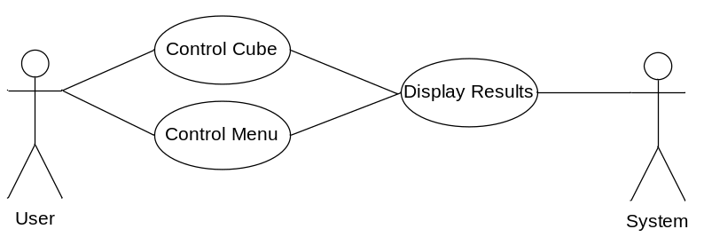
Figure 1
Figure 1 shows a general idea of the purpose of the Input Device. The Input System will allow the user to control the cube and interact with the menu when need be. The GameEngine will not know what input is being received, just that there are functions such as making the cube move, and that it is being assigned to a delegate in the Input System to be executed when it needs to be.

Classes

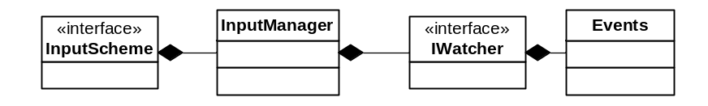
Figure 2
InputManager, IWatcher, and Events classes are the three main objects used for the Regade’s Cube class. Each play an important role making it easy capture certain events from the user and execute specified functions. Figure 2 shows a basic understanding how the classes relate to each other.

Input Manager
The InputManager is the manager for anything input related from any physical device. It will take multiple IWatcher interfaced objects, this will be described farther below. The InputManager’s job is specifically to accept and remove IWatcher interfaced objects as the parent class sees fit. Whenever the parent class requests so, the InputManager will update and all the IWatcher interfaced objects to do their jobs.
There will be one InputManager per state in the application. This means that each state will have its own input functionality. It is possible to have multiple InputManagers in a state, however for our application, it is not necessary.

IWatcher
IWatcher is an interface that is needed when creating classes used to watch input devices. The diagram (figure 3) below shows several of the objects using the IWatcher interface that is and will be used in the application.
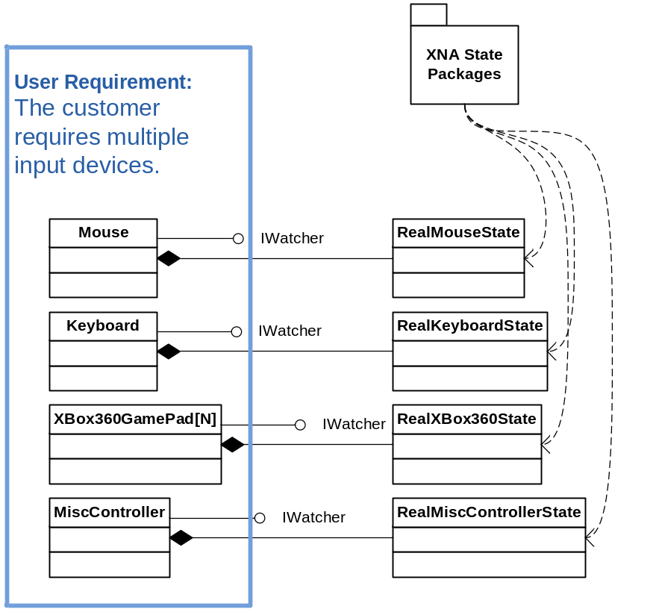
Figure 3
Not only is each object using the IWatcher interface, but also they need a object to keep track of the real state of the device. This is why each Watcher, an object interfacing the IWatcher, will aggregate a Real Object State class that keeps track of the state of the input device.
Watchers will also keep a list of Events objects, as it can be seen in figure 2. Watchers will allow adding and removing of events depending on the Parent class.

Events
Each event can be assigned a specific action that can be taken by the input device. These events are also assigned a function, so that when a Watcher finds that action to take place, it will execute that function.
However, each event will not only hold a given function, but it may also hold another event. This allows the watcher to check for multiple actions before executing the assigned function.
However, since there are a variety of input devices, that making a universal Watcher and Event would be nearly impossible. It was easier to create a Base Event, and derive all different Event types from that. The diagram (figure 4) shows this relationship below.
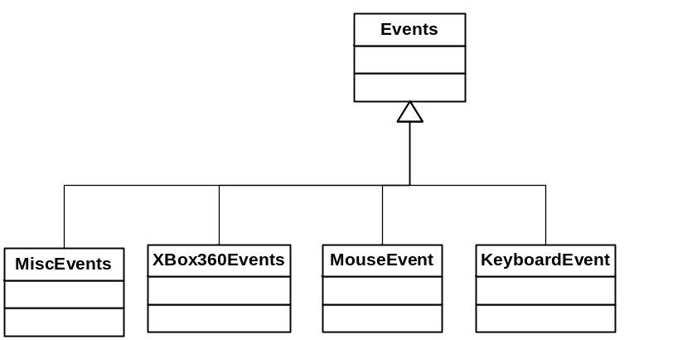
Figure 4
Each event inherited from the Events Class which is specific to the device. One should not use MouseEvents for the Keyboard watcher. The delegates in the events do not contain the same parameters. However, the Watcher will catch the error and throw a false value in result.

InputScheme
The input system also defines a templated InputScheme class. The class’s responsibility is to map a watcher’s events to a given object’s functions. The Generic InputScheme class takes a generic type argument. This generic type is the type of the object that will have its functions mapped to watcher events.
The Apply(T object) function of the InputScheme will keep a reference to the object and then call MapWatcherEvents(). This abstract function will be overridden to explicitly assign the object’s functions to a created watcher’s events."

States
Each device will have either a on/off input (buttons, switches) or analog inputs (joysticks, pedal buttons). For buttons, actions may be released, tapped, or pressed. The state chart below are the possible states or actions a button maybe in based on the user pressing the button.
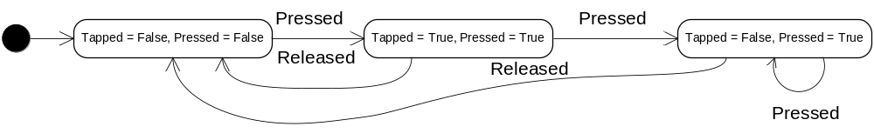
Analog input devices will either be in the state of release or lean, which the delegate will have parameters of current position and distance moved.

Sequence
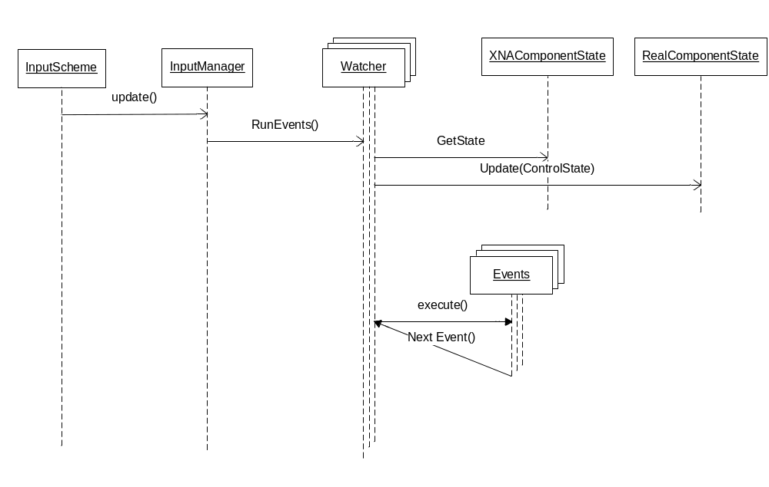
The Game State will as the InputManager to update. In which case, the InputManager will run through all contained watchers, and requests that it run any events it needs to execute. The Watcher will update and get the real state of the device it is watching. Then will run through the events and execute any delegates necessary. However, if another event is returned after executing the delegate function, then this will be tested to be executed.
Nothing is returned back to the InputScheme.

.

6.1.4 GUI

The GUI system provides support for user intractable scene objects to be used for games.
The GUI system uses the existing scene graph and rendering support to display and manage GUI objects. The goal of using the current SceneGraph support is to allow user interactable objects to exist within game scenes and still have the same GUI functionality as if the objects were flat 2D objects on the screen.

A GUIObject is an object that descends from the GUIObject class. A GUIObject is also scene graph object as the GUIObject class derives from Spatial and adds specific functionality in many ways.
- The GUIObject computes world bound as a flat rectangle in 3d space with a user defined width and height.
- A GUIObject’s rectangular region can be divided into a grid of pixels. . This allows the object to refrence screen coordinates even when its width and height in world units do not match the screen dimensions in pixels. This grid will usually correspond to the locations of screen pixels but is not required. The GUI will expose properties defining the pixel width and height of the object.
- The GUIObject has a world Width and a world Height that define how wide and tall the object is in world units. This is separate from pixel width and height; an object’s size can change and the pixel resolution can still be the same.

GUIObject also realizes the IGUIElement interface. This interface provides notification functions for all forms of user interaction. Any object that realizes this interface can be notified of user interaction from the GUIManager. The GUIManager’s responsibility is to inform controls that user input has occurred within an IGUIElement’s region.

In order for the GUIManager to function, the GUIManager will need a scene and a source for user input events. The GUIManager manages a single scene with IGUIElement in it. It will keep a list of all the GUIObjects that are in the scene, and use them to compute focus changes and selections. The GUIManager will also need to know when user input events occur. Therefore the GUIManager will keep a refrence to a GUIInputScheme object that defiens how input should affect the GUI.

The GUIInputScheme object will be abstract and only be more specific than InputScheme in one way; it will specify the generic type argument of InputScheme to be of type GUIManager. It will be left to further derived classes to define how the manager is affected by input. By default the GUIManager will use the GUIStandardInpudScheme. This maps all the intuitive key inputs and mouse events to the GUI manager.

The GUI system described so far does not support a completely flat GUIObject hierarchy. The standard node class is inadequate for handling GUIObject trees. The main reason for this is that GUI’s derivation of the Node class will be sufficiently different from Node’s current implementation. This justifies creating a new class with some similarities to Node.

The pane class will define add the ability for a GUIObject to have children. The Pane class will derive from GUIObject and therefore will inherit GUIObject’s flat properties. Pane will keep a list of GUIObject children and will override Spatial’s draw and update methods to ensure all of its children are drawn and updated.

Similar to Node, Pane will have a method to add children but only GUIObject children will be allowed to be added to Pane. When a child is added to a Pane, it is automatically resized appropriately to the parent’s pixel grid based on the pixel width and height of the child.

The UpdateWorldData() function will be overridden in Pane to resize its children appropriately. If a child screen width is changed then it will be updated by the parent to fit the parent’s pixel grid. Additionally the UpdateWorldData() function will call UpdateGS() for each of the children.

Here are the differences between Pane and Node:
Node | Pane
- Has Spatial children  - Spherical Bounding Volumes  - Updates Children | - Has GUIObject children  - Flat Bounding Volumes  - Updates Children and resizes them to match pixel grid.  - Has notion of pixel width and height

The GUI system will define the very useful GUI2DScene class. The GUI2DScene class is useful for creating 2D scenes such as menu screens and other flat scenes. The GUI2DScene constructor will take the size of the screen that the scene will be displayed in. Form this data, the class will automatically create an orthographic camera, and root Pane class defining the screen. Users of the GUI2DScene class will need to access the screen pane to add custom GUI objects. The GUI2DScene class will be derived from the Scene class defined in the StateManagement module.

GUIControls will be defined from Pane as they too represent flat regions that can contain other GUIObjects. GUIControls will expose control events similar to windows forms events to notify listeners that a control specific event has occurred. The control class will expose events and define members common to all controls. Derived classes will expose more control specific events.

The members common to all controls are:
- Enabled flag
- Can focus flag (perhaps this should be with GUIObject)
  - Perhaps tab index?
- A background image?

Events common to all controls
- Enter – when focus is given to a control
- Leave – when focus is revoked from a control

Controls
- Button
The button control is used to represent a click button. When no action occurs over the button, the button’s regular image is displayed. However, the button will show a different image when the button has focus, or is selected. This will require that each button will require 3 image assets to represent it.

The GUI system also defines a drawing primitive called a Quad. The controls will use the Quad classes to be the controls’ visible elements. A quad is simply a rectangle that can be drawn to the screen. Quad will be derived from GUIObject as it is a flat bounded region. Two derived versions of quad are known: Image Quad and TextQuad. One will render text to a rectangle and the other will render an image. The implementatins of these are straightforward.

6.1.5 Picking

The Picking system is used to determine if a scene object was selected by a mouse event. It uses 2D screen coordinates, a camera, and scene to determine what objects were beneath the mouse cursor on the screen. The 2D coordinates are the coordinates that are defined as the number of pixels in the x and y direction from the upper left corner of the screen. The camera is used for two purposes, to see if the screen coordinates are in the camera’s viewport and to project a ray, in world coordinates, through the scene to see if any objects intersect it. If an object intersects the ray, it is a candidate for selection.

The main part of the picking system is the PickingManager service. It exposes two critical functions:
- Pick(Vector2 screenCoords, Scene scene)
  - This function will project a ray using the Scene object’s camera and use the ray to determine any candidates.
- Pick(Ray testRay, Spatial root)
  - This function will test an arbitrary ray to see if it intersects any object within the scene graph defined by root.

Both functions return a list of candidate objects in the form of a PickRecord. The pick record holds all the candidates, allows for sorting of the objects and allows for filtering of types.

If the 2D screen coordinates and Scene object are given, the pick function must project a ray from the camera using the screen coordinates and the camera’s properties:
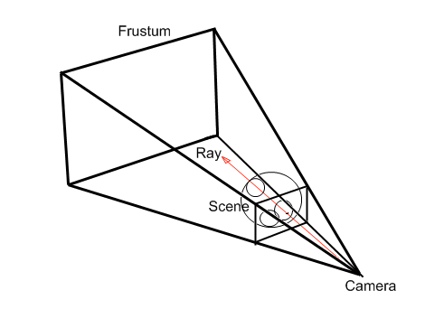

In order to find the ray, a test will see if the coordinates are in the scene’s camera viewport. If not, pick will return an empty pick record. If the pick is inside thje viewport, the ray can be found. The screen coordinates are then converted to the viewport coordinates and the ray is found by projecting the ray from the camera origin to the viewport coordinates on the near plane. The newly found ray will be passed to the other Pick function that will recurse through the scene graph and place any hits into a PickRecord.

The pick function will test the objects bounding volume if it intersects the ray, if it does, then the next step depends on the kind of object tested.

If the object inherits the INode interface, it will use INode’s functions to get the children. Once the children are retrived, pick will be called on all of the children, thus defining the recursion process. The INode object will be added to the pick record as well.
Else if the object is Spatial derived, the object will be added to the pick record.

Each object will live in the pick record based on the distance to the intersection. The closest objects will be first, and the furthest, last. The pick record exposes functions to filter out unwanted types and also allows to quickly get the furthest or the closest. The list of intersected items can be requested additionally.

6.1.6 StateManagement

Computer games typically have several screens and different phases of the game application. There are initially menu screens, a game play screen, pause menu, credits, etc. These are all examples of game states. States divide the game application into different operational modes. A state usually has a constant input scheme (which may differ radically from other states) and specific game logic found only in the current mode.

The engine defines the GameState class to encapsulate common functionalities between states and allow them to be extended for state specific logic and user input schemes. The common tasks to all games states are: updating, loading, and drawing scenes; updating input; and perhaps more for the future as more tasks become known.

The base state object has an instance of an InputManager for defining an input scheme specific to the state. The update function of the state will update the input manager this is common to all states.

In addition, the state class also has an instance of the SceneManager class. The scene manager provides a way for a state to have multiple scenes to be loaded, drawn, and updated. The SceneManager class will keep a collection of Scene class objects. The scene class represents a scene graph tree with a certain viewing point defined by a camera. The individual scenes can be enabled to be updated and set visible to be drawn.

The Scene manager will expose an interface for Loading, Drawing, and Updating. These functions will forward the requests to each scene in the scene manager’s scene collection. For scenes that are enabled, they will be updated. For scenes that are visible, they will be drawn.

The Scene class will expose a public property to get and set the scene’s camera. This will be used to determine from which viewpoint to render the scene. Upon a draw request, the scene will set the CameraManger’s active camera to the scene’s camera. This will ensue the scene is drawn with the correct camera.

The state class is derived from the XNA DrawableGameComponent class. These classes can be put into an XNA game’s DrawableGameComponent collection to be updated and drawn automatically.

The states are to be managed though the StateManager class. State manager is a service available to all game components that maintain a stack of states. The top state is usually the only active state, the states that are beneath the top state are not updated or drawn and are preserved. The top state can be popped off the stack to return to the previous state as it was left. This is particularly useful when there are many menu screens in a game and backward traversal through the menus is as simple as popping the states off the stack. This resumes the old states so that the cursor positions are exactly where the user left them so the user knows where he/she came from.

The state manager will have routines to push a state, pop the top state, and replace all states with a single state defined within the interface.
States are able to transition to different states by pushing, popping or replacing the states in the State manager class. The states themselves define the game flow and state machine.

Each state will have a function called when there has been a state change. This is so that the states can make changes based on the current state stack. A paused state that is pushed on top of the gameplay state should not stop the gameplay state from being drawn. The game play state will watch for the paused state on any state transition, if found, the gameplay state will be sure to keep its draw flag set to true.

